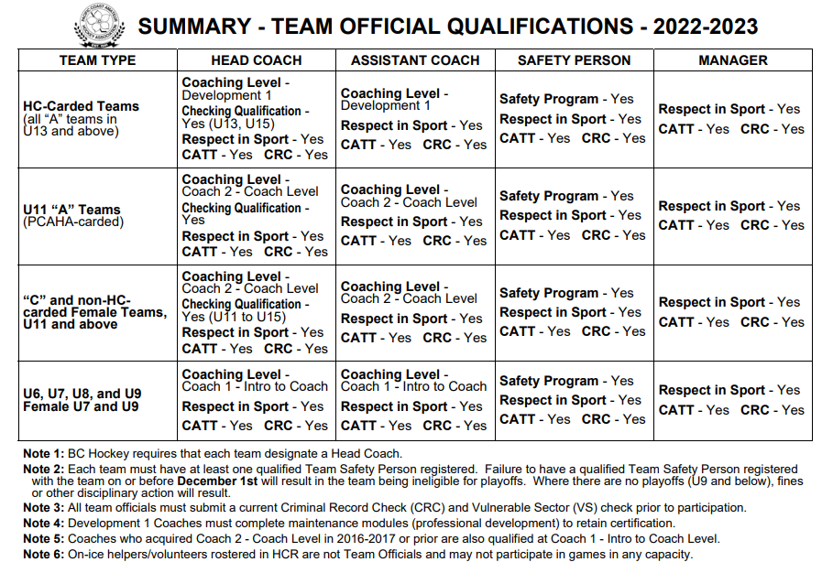
2023 – 24 COACH AND TEAM OFFICIAL CERTIFICATIONS

CERTIFICATIONS:

- Respect in Sport: https://bch.respectgroupinc.com/
  - Coaches and Bench Staff: Please do “Activity Leaders” option
- Concussion Awareness Training Tool (CATT): https://cattonline.com/coach/
- Criminal Record Check: Please visit: https://justice.gov.bc.ca/criminalrecordcheck
**Enter access code: 6U5AKYGDY9 and follow NEW submission instructions**
- ONCE APPLICATION SUBMITTED: You MUST send a screenshot of the completed submission to registrar@coqmha.org so that we can submit and check it off
* Be sure to keep your session ID number for your records.
MOST SUBMISSIONS WILL BE COMPLETE AFTER STEP 2, HOWEVER, IN SOME SITUATIONS, YOU MAY BE PROMPTED ONLINE OR BY MAIL THAT YOU ARE REQUIRED TO COMPLETE ONE (1) OF THE FOLLOWING.
UNABLE TO VERIFY - PLEASE PRINT OUT: If you experience issues with the online program verifying your information, it may request you to print out the application. If this occurs, please sign and email or mail, along with two (2) scanned copies of government issued IS to crc@bchockey.net / 6671 Oldfield Road, Saanichton, BC V8M 2A1. BC Hockey will forward these to the Ministry of Justice.
CONFIRMATION OF IDENTIFICATION: If requested to provide proof of identification, please email legible scan or photo of two (2) pieces of government issued ID to crc@bchockey.net with your session ID number. BC Hockey will forward these copies to the Ministry of Justice and issue an 'Interim" CRC approval, which will allow for clinic registration.
FINGER PRINTING: If requested to complete finger printing, please do so at your local police detachment ASAP. Send confirmation of your finger print submission to crc@bchockey.net. There may be a charge for the finger printing service dependent upon the police station you visit. Should you wish to be provided a letter of reference that identifies you as a volunteer with BC Hockey to assist in a waiving of this fee, please send your request to info@bchockey.net.
- Coach Clinics: https://register.hockeycanada.ca/clinics (Click on “Coach” option)
- Safety Course (*HU – ONLINE SAFETY): https://register.hockeycanada.ca/clinics (Click on “Trainer/Safety” option)

*The Registrar will be in contact with each team to let their bench staff know what certifications they require to be eligible on their team’s roster.

IMPORTANT CERTIFICATION DEADLINES:
*Before stepping on the ice you must have RIS, CATT and Applied for a CRC
To check if you are missing qualifications follow the link below
https://account.spordle.com/login
Create a new account if you do not have once then click on link a member and type in your name and birth date
*Dec. 1:
-Safety program (HCSP) deadline.
- Deadline for coaches of HC-Carded teams to attain required coaching levels
- Deadline for all initiation and novice coaches to attend a Coach 1 coach clinic.
*Dec 15:
- Deadline for all non-HC carded coaches (U11 and above) to attend a coach 2 clinic.
- Deadline for all U11 – U18 Head Coaches to have completed the Instructional Stream Checking Clinic.

